Stagecraft

EXAM #1 – Study Guide

Identify different theatre spaces: Proscenium, Thrust, Arena

Proscenium Separates the audience from the theatre. What is on the stage at any moment looks like a picture to the audience

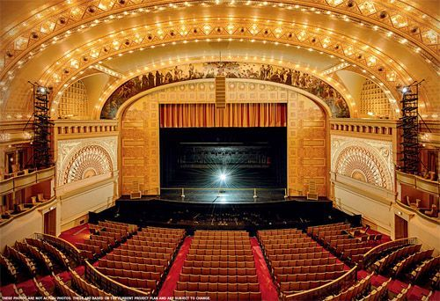

Thrust – Stage is out in the open and surrounded on three sides by the audience

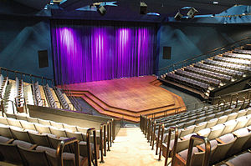

* Arena – surrounded on all sides by audience

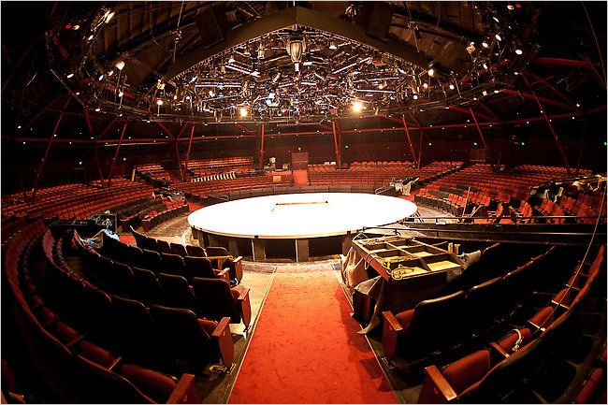

Know lumber grades for Plywood and Dimensional lumber

The different grades of wood are basically “how good is the wood and what should I use it for.”

Plywood – Thin sheets of wood usually used as surfaces for decoration (floors is a good example). Plywood can have “knotholes” in it, which is those dark circles you see in floors that makes the rest of the wood bend around it. Google pictures of knotholes if you are confused. Knotholes are bad things for wood quality.

* A – Looks good front, sound surface otherwise – Good wood
* B – Looks good for natural appearances, has defects but sound if buyer says – Still mostly good wood but not perfect. Has some knotholes.
* C;D – Sound surface but unlimited color variation, open defects and knotholes up to 4” otherwise – Ugly wood, you don’t want your house to be made out of this, and can have holes in it.

Dimensional lumber – This is the wood that you ‘build stuff’ out of. 2x4s are a type of lumber wood. You usually wouldn’t use this kind of wood for floors because it looks kind of naked. These are separated into “Grade categories.” Under the grade categories are the individual grades for this kind of wood.

* Structural Framing – Good for holding heavy things
  + Select Structural - Best
  + No 1 – second best
  + No 2 – third best
  + No 3 – fourth best
* Structural Joists and Planks - same as above but cant hold as heavy things
* Light Framing – Not very good at holding heavy things but still good for holding other things
  + Construction - best
  + Standard – second best / normal
  + Utility – third best
* Studs – Not very good, only good for holding walls really.
  + Stud – For holding walls
  + Economy Stud – really shitty wood, you only want to use this temporary and you really don’t want to try to “build” stuff out of this.

True dimensions of 1x4 and 2x4

1x4: 2x4:

0.75 x 3.5 in 1.5 x 3.5 in

Know the common dimensions for “Stock Platforms”

Basically, what the dimensions usually are.

4x8

4x4

2x8

2x4

2x2

Components of paint

Base

Resin

Binder

Pigment

If you’re feeling comfortable with the rest of the study guide, maybe look up some more of these paint components.

Parts of the paint brush

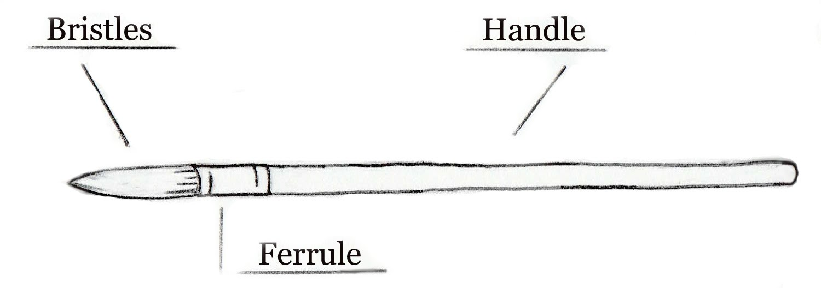

How is Latex paint disposed of?

It is recycled.

What does OSHA stand for?

Occupational Safety and Health Administration

Identify the clove hitch and bowline knots.

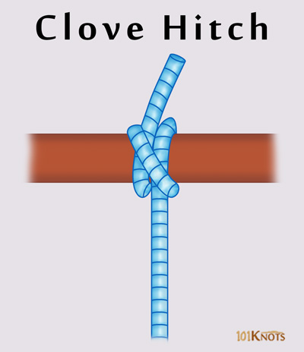

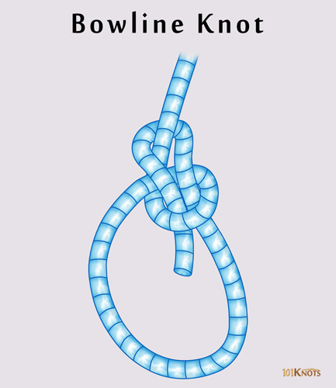

Identify the following tools:

The name of each picture and some good information about it is on the page after.

Look over this a few times and you’ll be good to go. There is not a lot he can ask you about these tools.

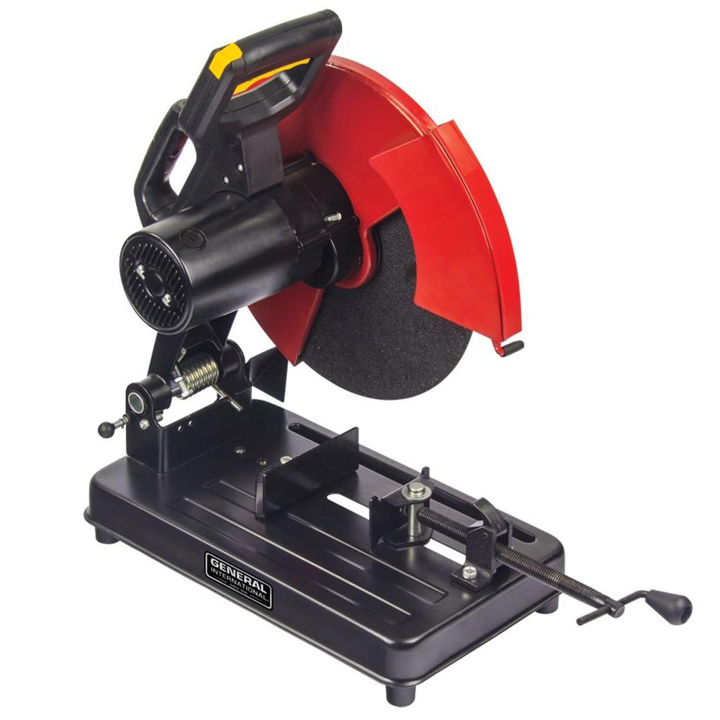

Mitre Cut Chop Saw

Circular saw cuts from above. Good for cutting long but thin pieces of lumber.

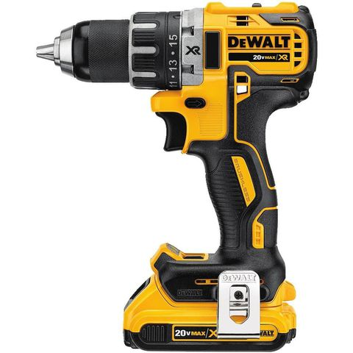

Cordless Drill

Drills stuff. Has a flashlight on it sometimes.

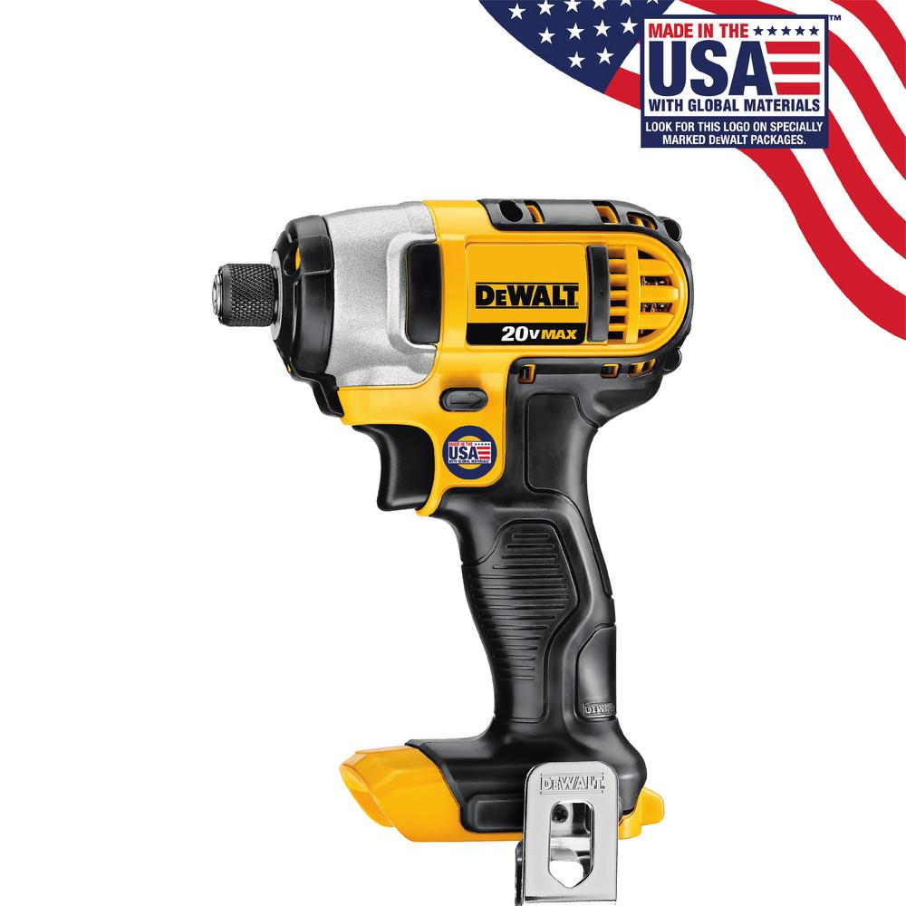

Cordless Impact Driver

Tightens bolts to nuts fast and strong. Used on car wheels.

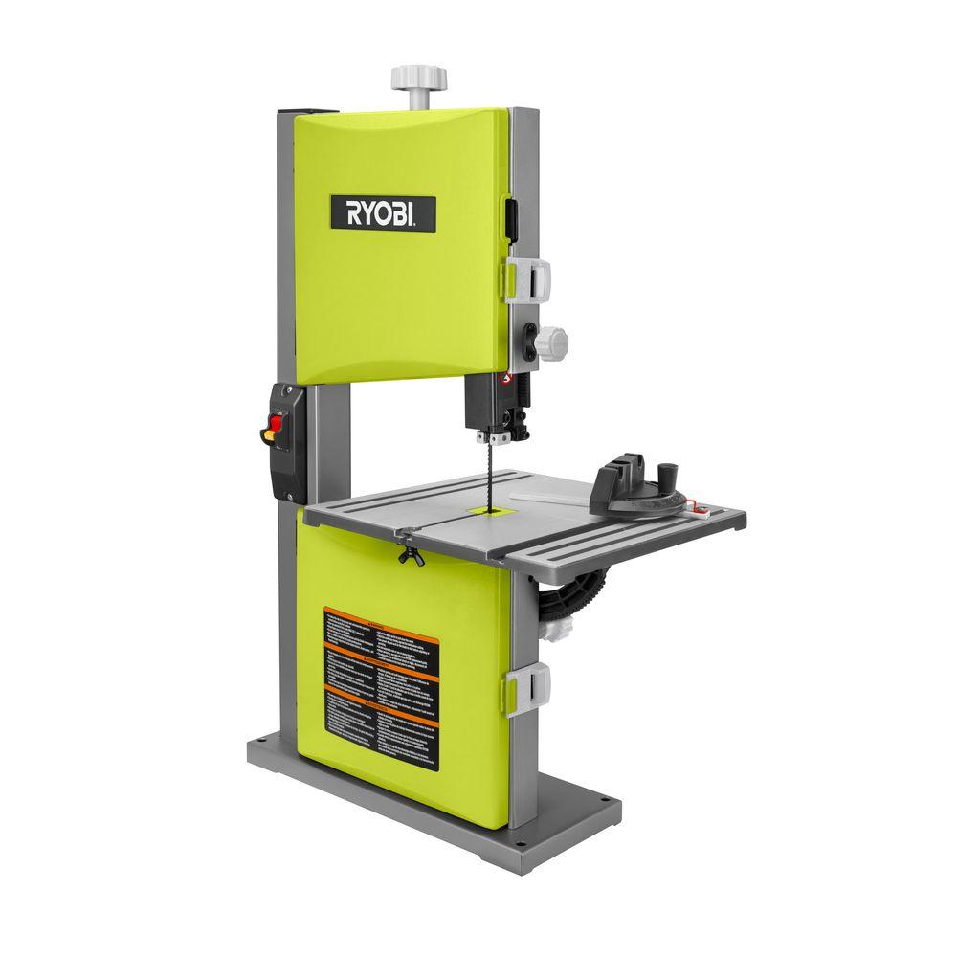

Bandsaw

Good for cutting sheets of wood in most sizes. Can cut in curves and corners.

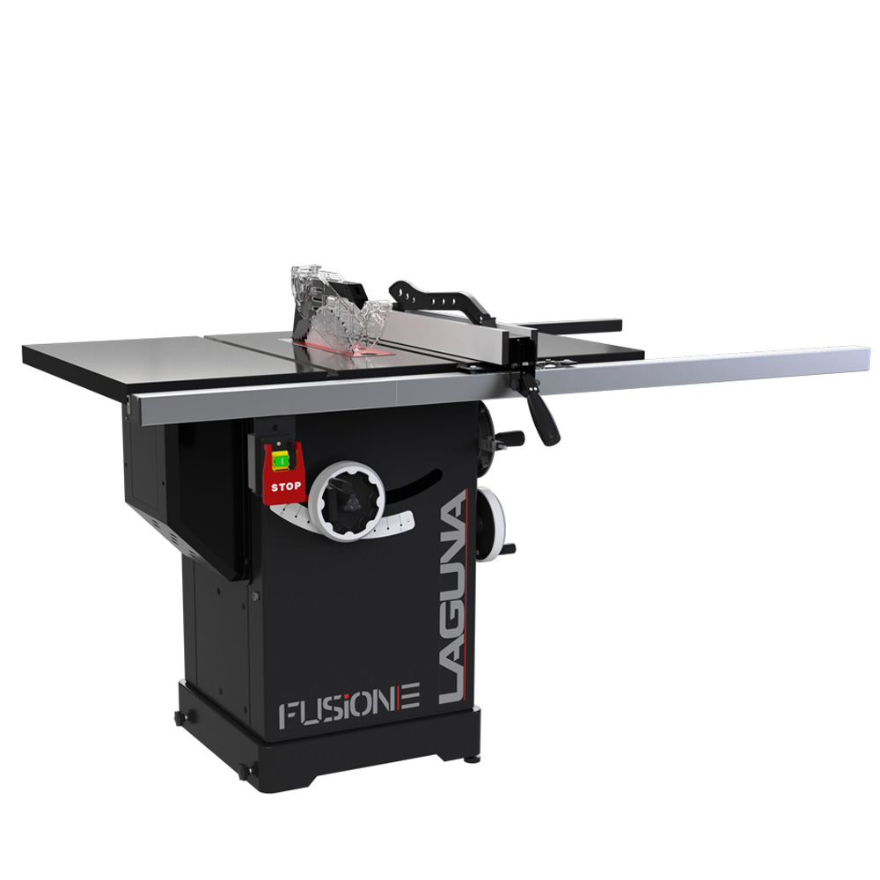

Tablesaw

Good for cutting long and wide pieces of wood sheets, but can only really cut in straight lines.

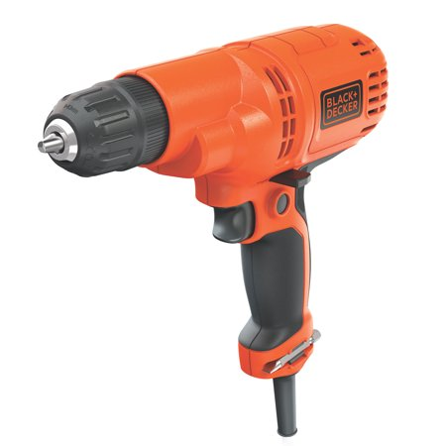

Corded Drill

Also drills stuff, but not as cool.

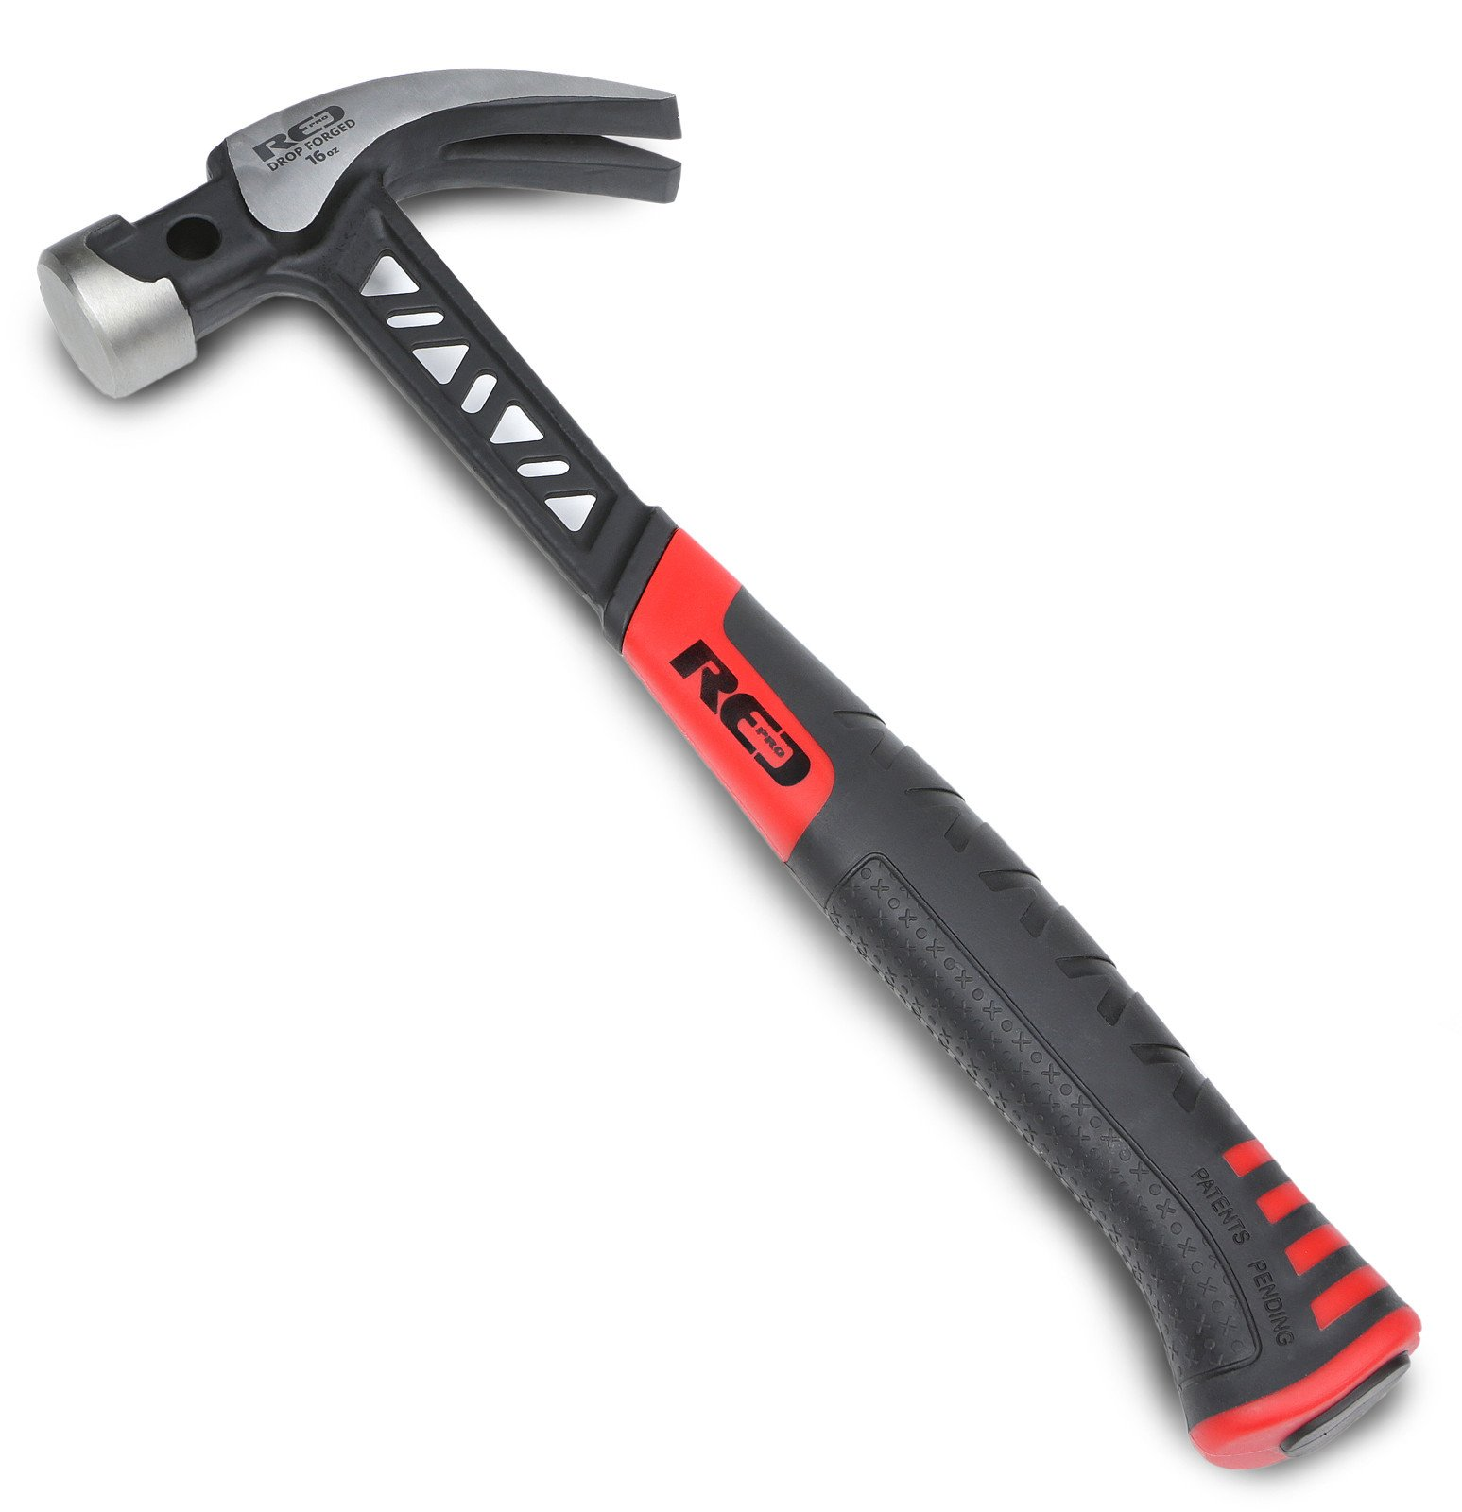

Claw Hammer

Used to fasten things with nails. The claw (the teeth) is used to pull nails out.

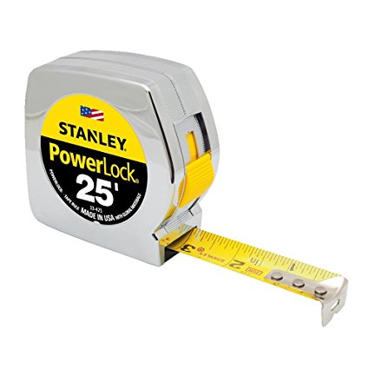

Tape Measure

Measure tape.

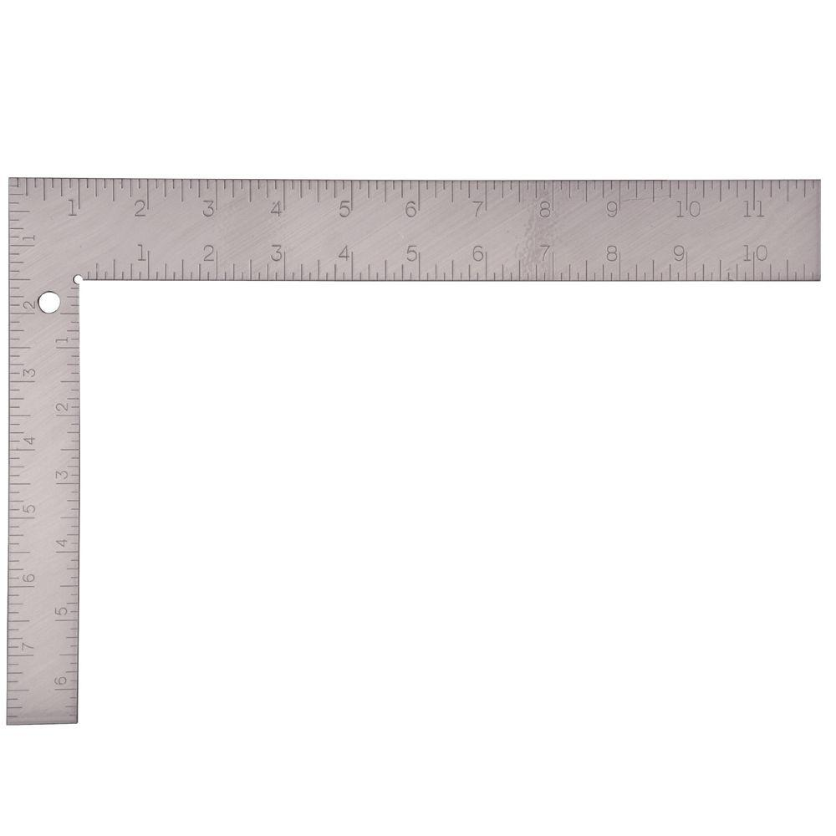

Carpenter’s Square

Used to draw 90-degree angles and do some measuring. I don’t really know what you would measure with this, but you probably do.

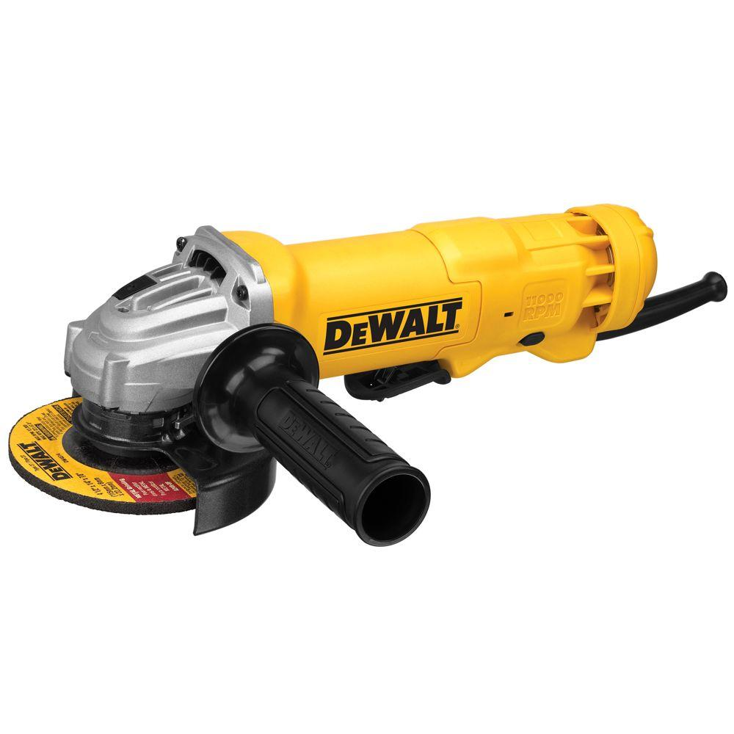

Angle Grinder

Makes sandpaper spin really fast to smooth out surfaces and edges of wood. Use on corners to round them out or on flat faces to get rid of splinters that can get stuck in your fingers (Yuck!).

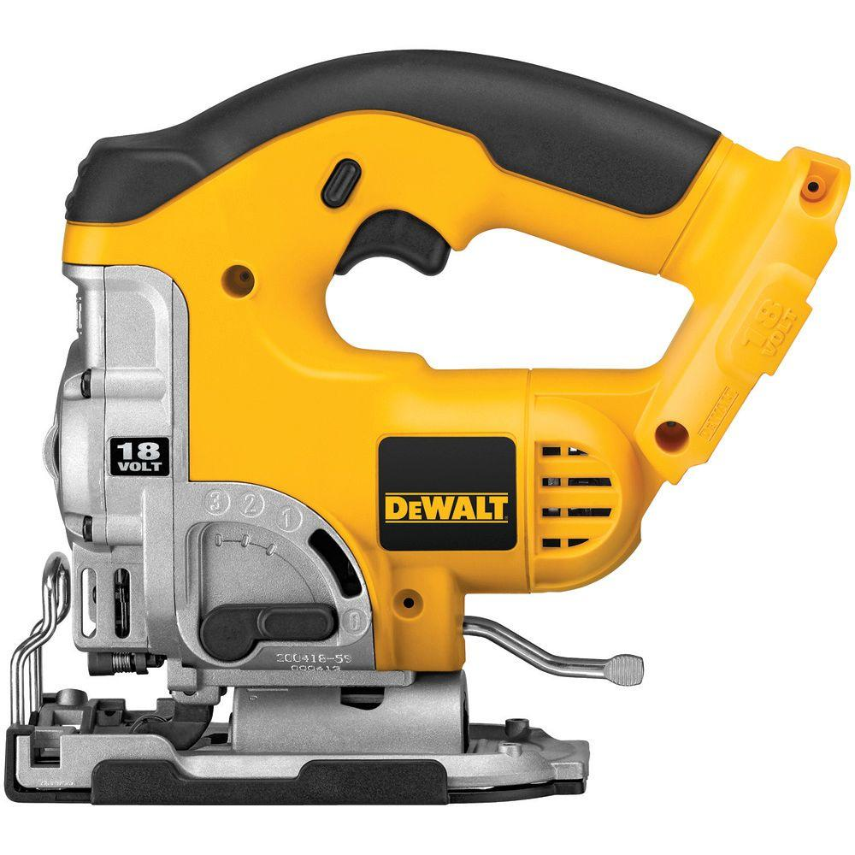

Jigsaw

Basically a saw that you hold in your hand. You use this one if you can not use any of the other saws, but it won’t cut through thick wood very well.

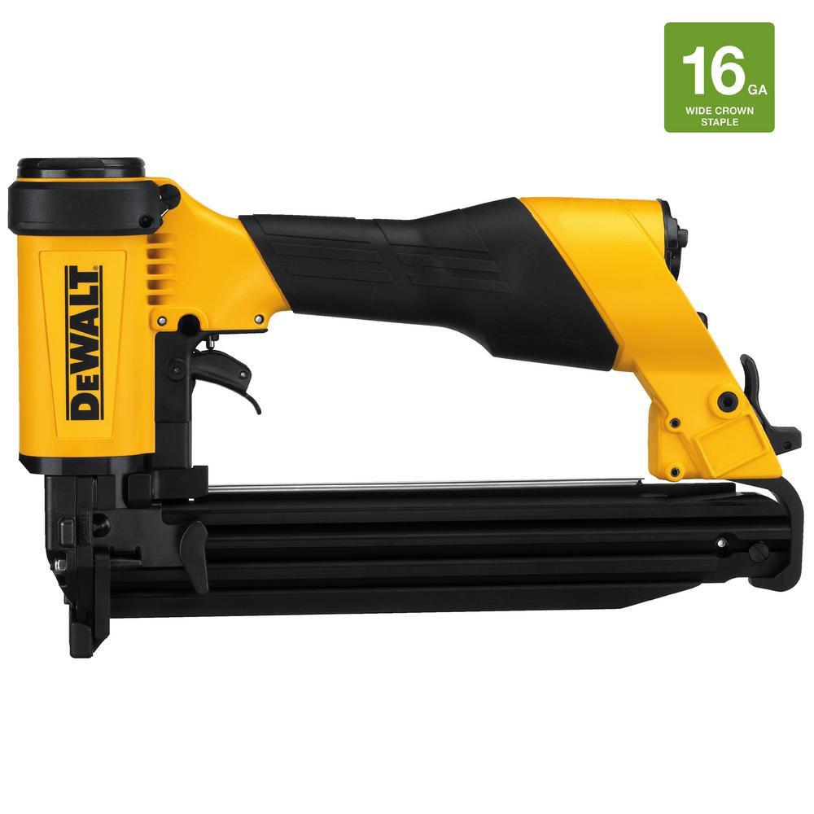

Pneumatic Stapler

Staples things fast and strong. Don’t staple your engineering homework with this.

Identify the following connectors:

Nails – Like screws but without grooves (grooves are what the circles are called. I think you called them teeth)

Screws – Sharp and goes into things to hold other things

Bolts – Like screws but they aren’t sharp and you put nuts on them instead.

Staples – not a stapler. The stapler is the thing that looks like a gun, but the staple is the thing that actually holds stuff together.

Identify and label the parts of a Soft Cover Theatre Flat

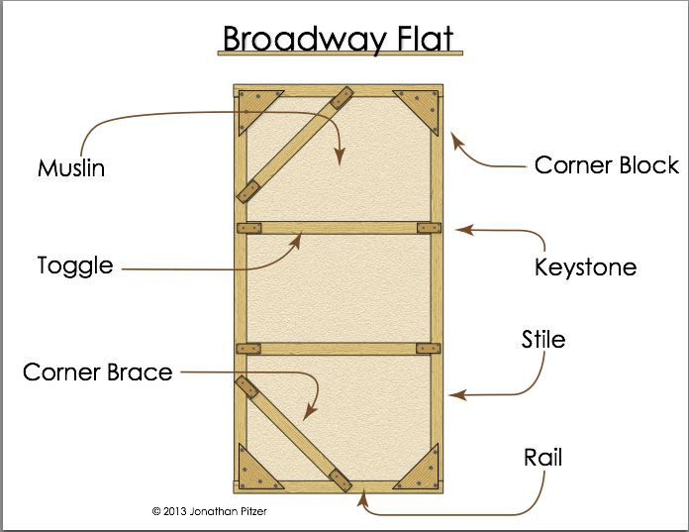

Just Memorize this as best as you can.

Identify and label the parts of a Single Purchase Counterweight Fly system.

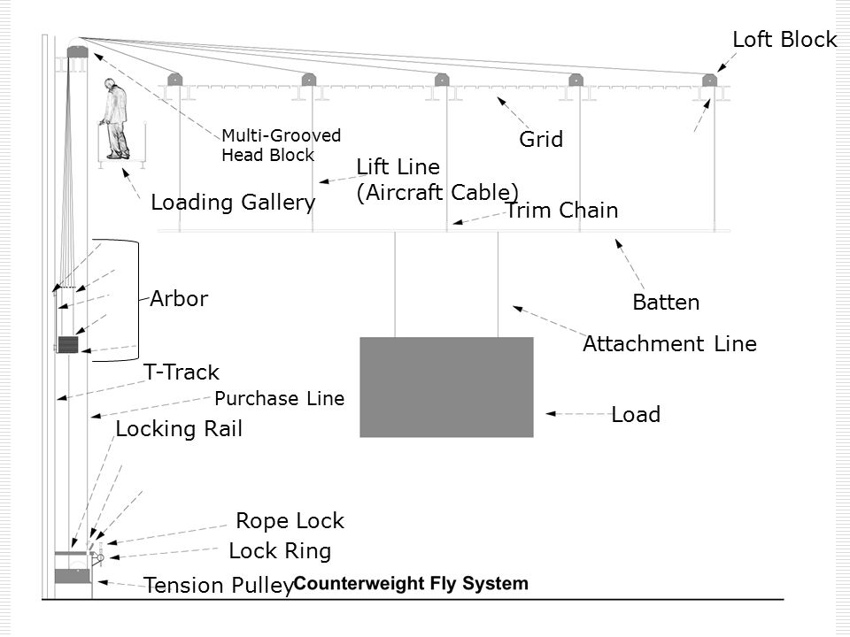

Same with this one.

Know safety protocols for working in the shop and on stage.

Basically just know the rules for not hurting yourself:

* Wear goggles
* Keep your hand away from moving machinery
* Don’t stand under heavy stuff being held up on stage.

You know how to use the machines.